Victorian Serrated Tussock Working Party

Community Assistance Program
Guidelines & Application Form
Version Date: 29 May 2019

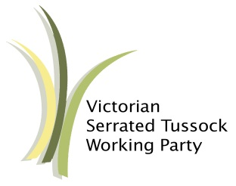

The VSTWP Community Assistance Program seeks to support communities to reduce the impact of serrated tussock (Nassella trichotoma) on agricultural, environmental and social values.
The program aims to tailor services to local attributes, level of community support and the density of the infestation. The VSTWP will attempt to provide assistance or advice for each application.

VSTWP Assistance Categories

One Season of Mapping and Education
Supports communities with very low levels of serrated tussock or are at risk of infestation. VSTWP to lead delivery of community awareness and education program to increase the community’s ability to identify and manage serrated tussock:
- Deliver one season of property inspections to map serrated tussock and increase community awareness.
- Promotion of project through media articles, social media and stakeholder engagement.
- All infestations identified are to be referred to Agriculture Victoria to ensure ongoing management.

Two Seasons of Mapping and Education
Support communities with medium to high infestations as well as high agricultural, social or environmental values. VSTWP to lead delivery of community awareness and education program to increase the community’s ability to identify and manage serrated tussock:
- Ensure community commitment and support for the project.
- Delivery of at least two seasons of mapping and education by a VSTWP Extension Officer.
- Promotion of project through media articles, social media and stakeholder engagement.
- After two seasons the few remaining landowners who demonstrate a low level of engagement will be referral to Agriculture Victoria for compliance support.
- On completion of the project will be handed back to a local lead agency. This agency will be responsible for maintaining action and support for the project through annual monitoring and education efforts. Where a new or existing landowner is found to fall behind in their management of serrated tussock, after exhausting all efforts, the local lead agency may request further VSTPW assistance for one or two properties within the area.

Assistance Package
Support communities with medium to high infestations and lower agricultural, environmental or social values. VSTWP to facilitate community awareness and education programs which increase the community’s ability to identify and manage serrated tussock including:
- A grant to deliver a best practice field day, along with educational material, promotion through the VSTWP and guidelines for running the event.
- Provide exemplary landowners with fence signs to promote best practice.
- The VSTWP will accept other suggestion for assistance.

Criteria
The following criteria are used to assign the project to one of the three assistance categories:
- Level of agricultural and environmental values.
- Level of community support and action.
- Density of infestations in the area.

Project Requirements
- A representative for the local lead agency is to be nominated as a key contact. If the project is supported, the key contact is expected to make themselves available to meet and liaise with representatives of the VSTWP regarding all project matters.
- For the delivery of mapping and education, the project area is to be no greater than 15,000 hectares in size and contain no more than 200 properties.
- For the delivery of mapping and education, the project must be within a defined area and ideally have clear boundaries such as roads, railway or reserves.

Evaluation of Applications
A VSTWP Advisory Committee will evaluate applications against the criteria, taking into consideration information provided by the applicant, VSTWP Extension Officers and Agriculture Victoria.

Eligibility for support via this program is at the discretion of the VSTWP Committee. As funding and resources are limited the VSTWP may not have the capacity to support all requests for assistance.

How to Apply
If you are interested in being part of this program and working with the VSTWP to manage serrated tussock, please complete the attached application form and submit to the VSTWP for consideration. Applications will be tabled and assessed at the next scheduled VSTWP Advisory Committee meeting after which the applicant will be informed of the decision.
For further information please email the VSTWP at info@serratetussock.com
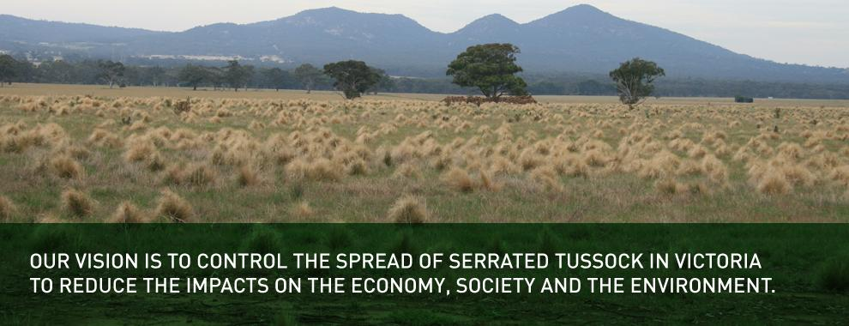
Community Assistance Program: Application Form

Contact details of local lead agency representative E.g. Landcare, Local Government:
Local lead agency:
Contact Name:

Phone Number:

Email Address:

Postal Address:

Number of properties in the project area:
Collaboration and Partnerships: E.g. Landcare or community groups, Local Government, Parks Victoria

Agricultural and environmental assets in the area:

Level of community support and action: Details of the serrated tussock control works undertaken in the area, including length of time. Provide any supporting evidence demonstrating community-led action, such as surveys or field day attendance: (Attach additional pages or supporting documents if required)

No of properties with infestations:
Average density of infestation ( 0-1% / 1-5% / 5-100% ):
Average number of plants on infested properties ( less than 100 / up to 1,000 / more than 1,000 ):
Number of problem properties impacting on groups control efforts:
Have attempts been made to contact these landholders? Y / N
Details:

Has the group/organisation sort assistance from Agriculture Victoria / Local Government / other? Y / N
Details:

Please provide any other evidence to support your application or ideas for the type of assistance you require. (Attach additional pages or supporting documents if required)

* Please attach a map detailing the project area. Location of properties actively managing serrated tussock. Location of properties requiring attention - include road names, waterways, etc.

Name:

Signature: Date:

Please send your completed form to: info@serratedtussock.com
or post to:
Executive Officer
Victorian Serrated Tussock Working Party
219a Main Street
BACCHUS MARSH, Vic 3340

